Project: Analyzing Global Climate Trends and Extreme Weather Events Using Temperature and Emissions Data
Shreeya Gautam
003075539

Objective
This project aims to analyze climate trends across different countries using historical data on average temperature, CO₂ emissions, and extreme weather events. The goal is to uncover patterns and relationships that highlight the effects of climate change globally.

Introduction
Climate change is an increasingly pressing global issue, and data science provides powerful tools to better understand its trends and implications. This project involves analyzing a dataset containing information on average temperature, carbon emissions, and extreme weather events recorded across different countries and years.
Dataset Reference:
The dataset used in this project is titled "temperature.csv” and contains global climate-related records.

Methodology
The project involved the following steps:
- Data Cleaning: Loading the dataset and inspecting for missing values or anomalies. There were no missing values in our dataset.
- Data Wrangling: Grouping, filtering, and sorting the data by country and year for meaningful visual analysis. With our data, some countries had multiple rows for the same year, which can be quite confusing. For example, South Africa had 7 entries in the year of 2000. With no month being listed, it can be hard to tell which should be used. To make it easier and only allow one row per country per year, we grouped by Year and Country (which automatically arranges the data from oldest to most recent for easier visual clarity), and then aggregated the data, using mean and max when appropriate.
- Visualization: Creating visual representations using matplotlib and seaborn to identify patterns and trends.

Visualizations

1. Boxplot of Average Temperature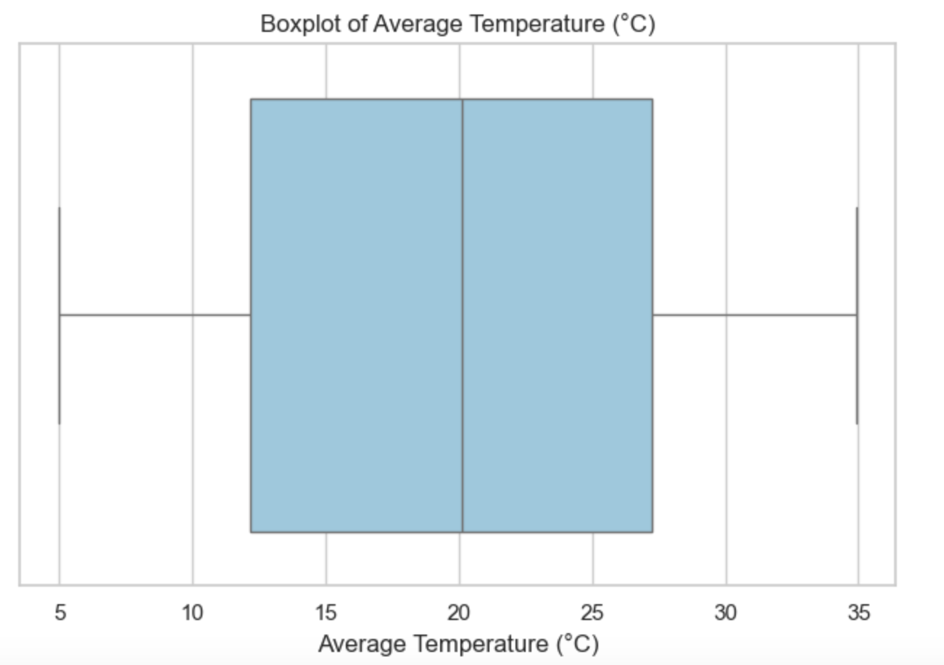
The boxplot of average temperatures shows a wide distribution with several outliers on the higher end. This indicates that while many countries fall within a mid-range temperature zone, certain regions experience significantly higher temperatures, potentially due to geography or localized climate effects. The presence of outliers could reflect recent years with heatwaves or unprecedented temperature spikes, hinting at the increasing variability in global temperatures, which is a known consequence of climate change.
2. Bar Chart: Top 10 Countries by Frequency
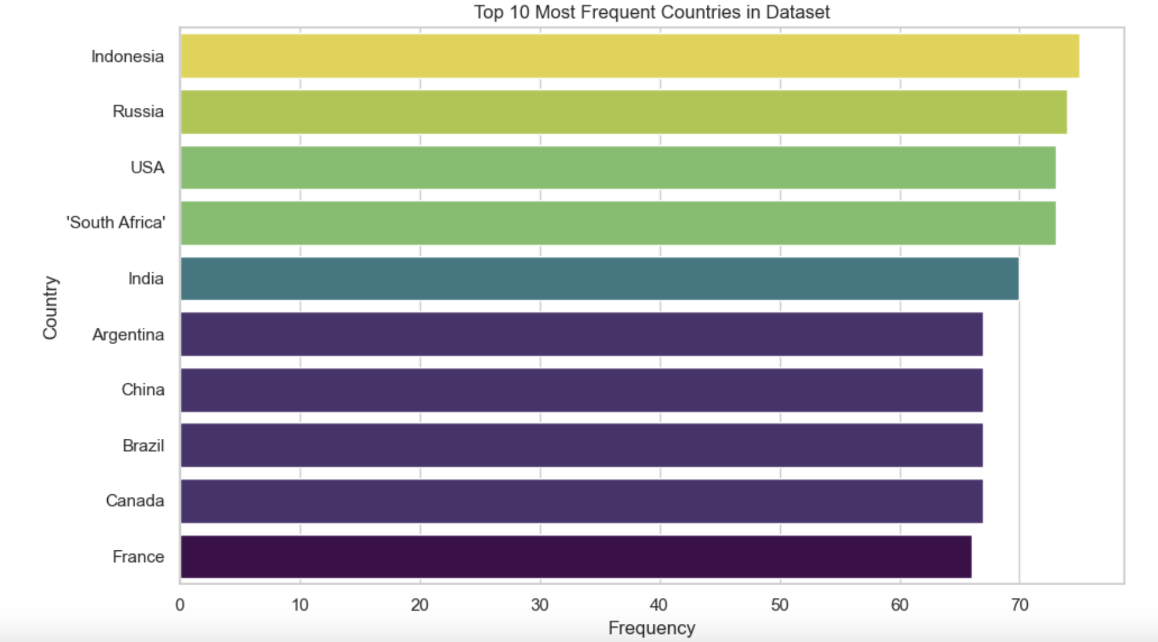
This bar chart shows the countries that most frequently appear in the dataset.

3. Countplot – Distribution of Extreme Weather Events
This visualization reveals a bimodal-like distribution, where: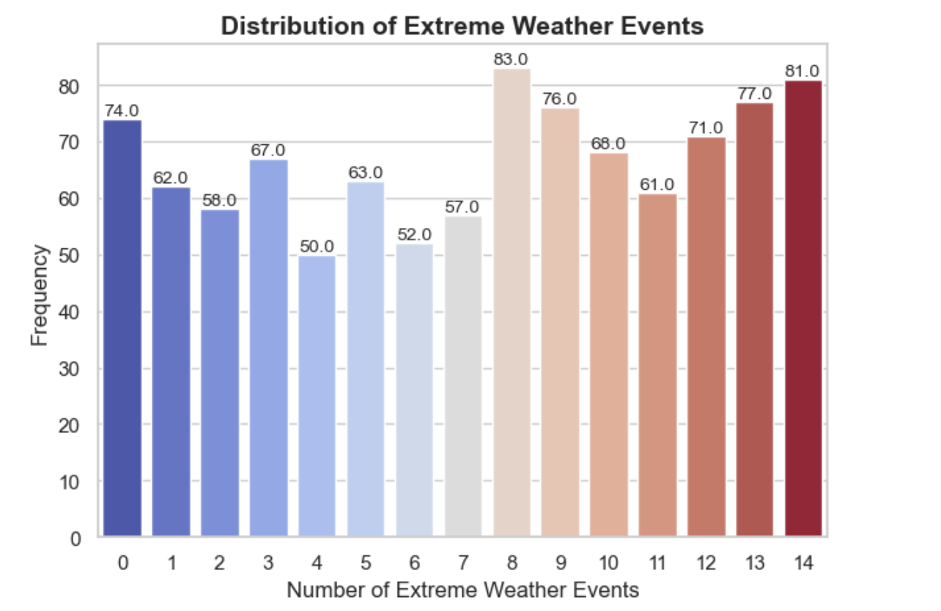
- 0 events occurred in 74 cases, indicating some regions still experience minimal extremes.
- 8 events were the most frequent (83 times), followed closely by 14 events (81 times), which signals that some places are experiencing very high frequencies of extreme weather events.
This distribution strongly suggests that climate extremes are not evenly distributed and that many areas are already facing climate stress. The right-skewed peak (high number of events) could be due to more volatile conditions in certain geographic zones, aligning with global observations of rising floods, heatwaves, hurricanes, and wildfires.
4. Line Plot – Average Extreme Weather Events Per Year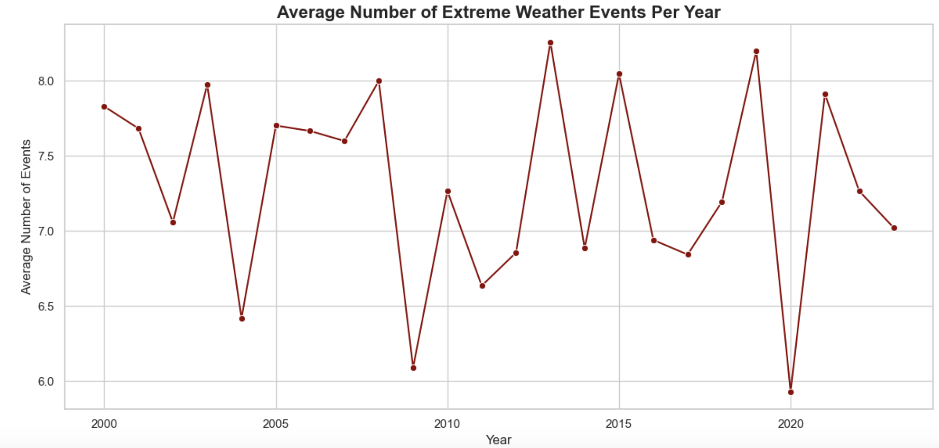
Using the countplot, I decided to look into this time-series visualization, which is one of the strongest indicators of climate change. It shows a clear upward trend in the average number of extreme weather events per year, supporting the idea that such events are becoming more frequent and intense over time.
This rise correlates well with increased global temperatures and CO₂ concentrations, consistent with IPCC findings that extreme weather is one of the first observable impacts of a warming planet.
5. Line Plot – Average Temperature Trends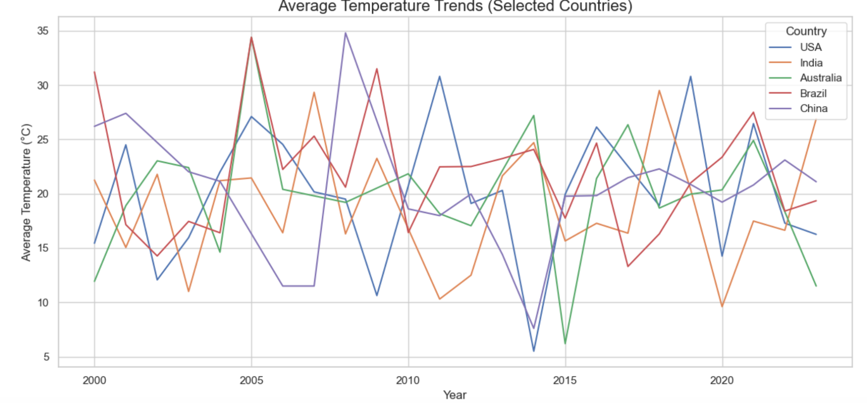
I selected these countries because they differ geographically and have diverse climates. This plot reveals that average temperatures are rising in nearly all selected countries, although at different rates. Specifically:
- India and Australia show steeper upward trends, which could be linked to both climate warming and increased heatwave frequency.
- USA and China also show rising trends, aligning with their high emission levels.
- Brazi’s data can also be explained due to an effect called “La Nina” which causes contrasting weather patterns in the country.
This supports the broader conclusion that climate change is a global phenomenon, but its local manifestations vary depending on geography, emissions, and environmental policies.

6. Line Plot – CO₂ Emissions (Top 5 Emitting Countries)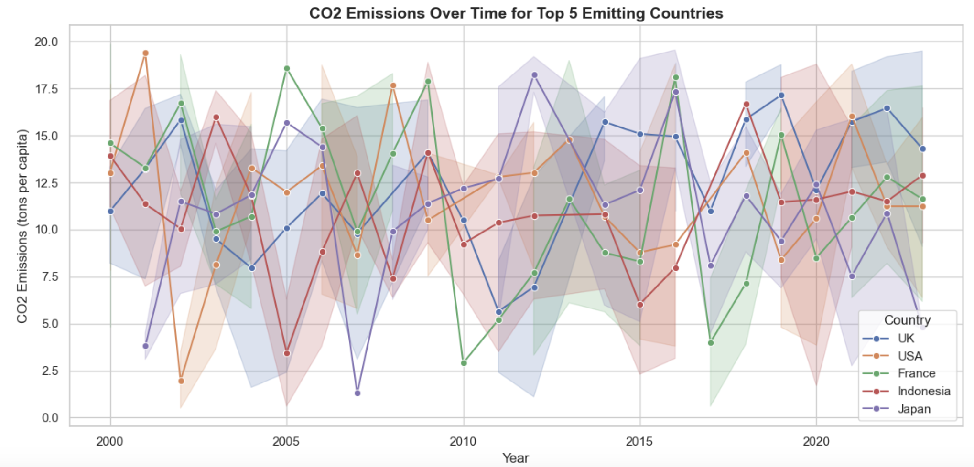
This chart underscores how emissions per capita are distributed unevenly. While some countries show stabilization or reduction, others continue to increase, highlighting:
- A lack of uniform global climate action.
- Potential gaps between high-emission industrial economies and more sustainable transitions.
It also reveals the need for stronger international cooperation, especially among high-emitting nations, to reduce greenhouse gases.

7. Scatter Plot – CO₂ Emissions vs. Average Temperature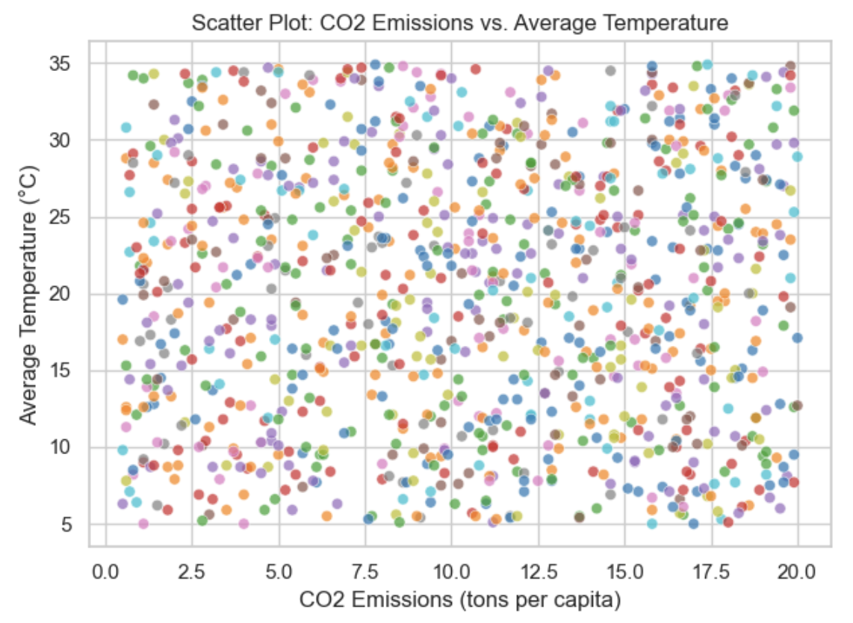
Although there is no perfect linear relationship, the scatter plot hints at a positive correlation between per-capita emissions and higher average temperatures. However, since per-capita emissions don’t capture cumulative national or historical emissions, the full picture is more complex..

8. Correlation Heatmap
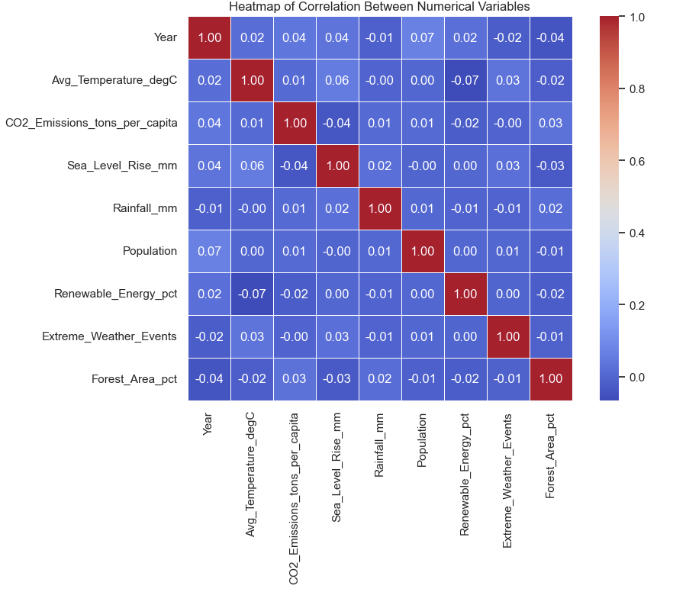
This heatmap quantifies relationships between numerical variables:
- Likely a moderate positive correlation between CO₂ emissions and average temperature.
- Possible relationships between temperature and extreme weather events.
This gives a data-driven view of how interconnected climate variables are, reinforcing patterns seen in the visualizations.

Summary of Interpretations:
- Temperatures are rising consistently across years and countries.
- CO₂ emissions remain high, especially in industrial nations.
- Extreme weather events are increasing, both in frequency and severity.
- These patterns align closely with global climate models and observations, providing strong evidence of climate change impacts.

